**What are Runnables in LangChain**

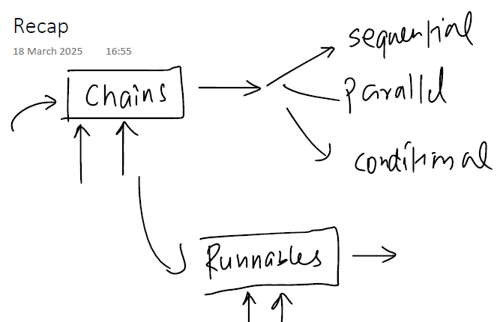

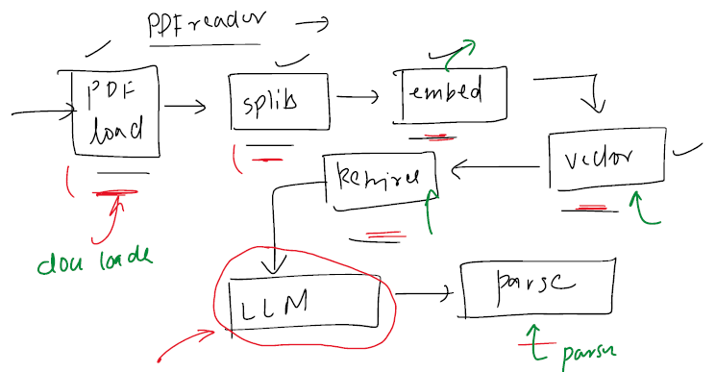

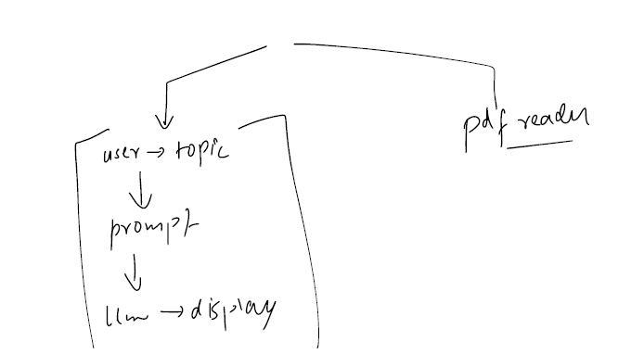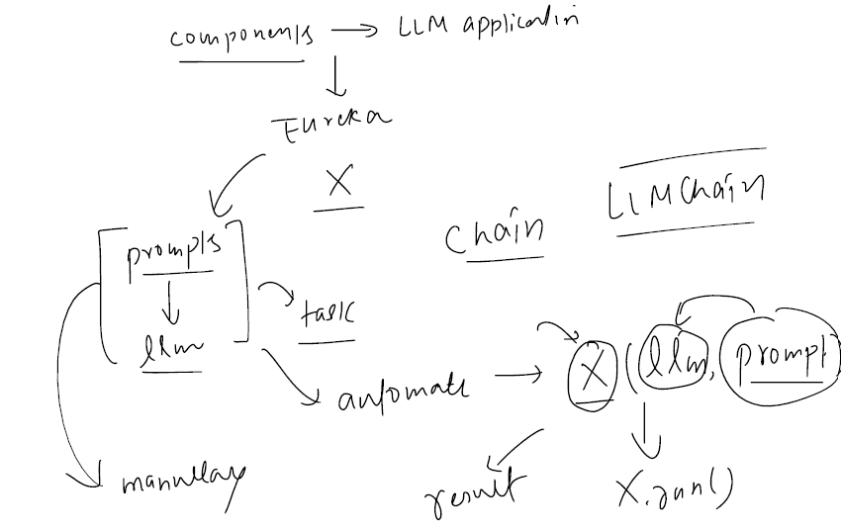

**Too many chains**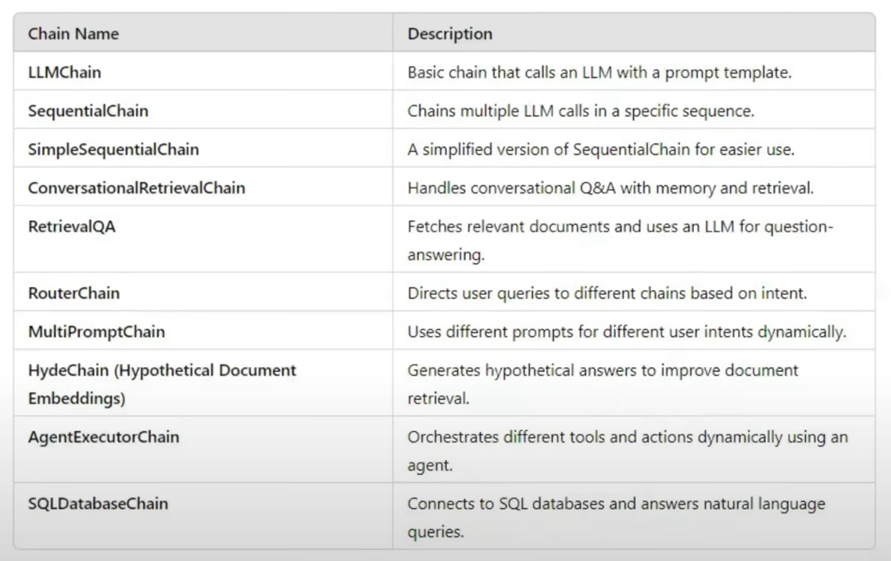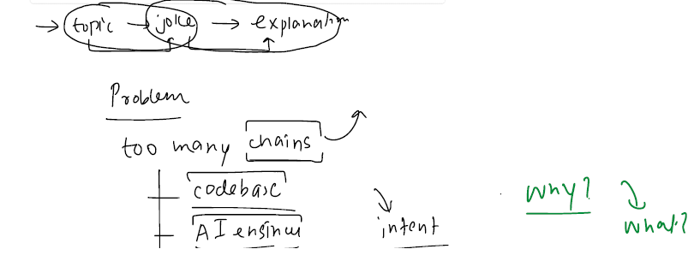

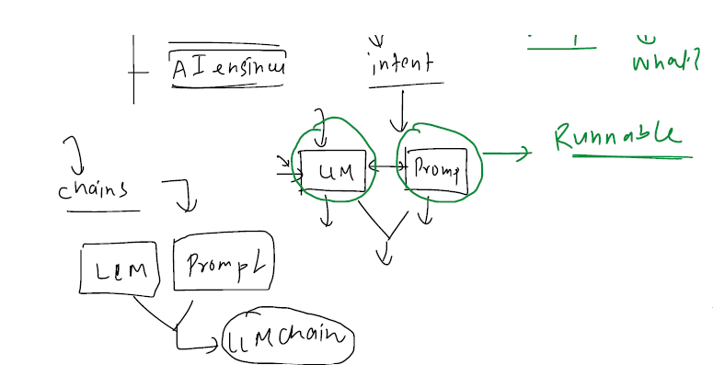

Runnables



